
Update date, xx xxxx

Visa Debit Card Dispute Management
PROCESS

October 1, 2026

Document Tracking and Control Table

Policy Owner | TBC
Approval Date | TBC
Version | TBC
Access Level | TBC
Policy Author | TBC
Subject Matter Expert(s) | TBC
Last Full Review Date | TBC
Update Date (changes were made but a full review was not necessarily conducted) | TBC
Review Frequency Requirement | TBC
Changes made | TBC
Stakeholders Impacted | TBC

Purpose
The Visa Debit Card Dispute Management Procedure guides the Growth, Payment Services, Fraud Prevention, and Finance teams in managing member-initiated Visa Debit Card disputes. It sets out a consistent approach for receiving and triaging dispute claims, gathering and assessing supporting documentation, issuing provisional credit, submitting and managing disputes through Central 1 and the Visa network, and resolving disputes and recovering funds where applicable. It also covers the roles and systems involved, the process flows, and the detailed procedures across the dispute management lifecycle.

Scope
This procedure applies to all team members involved in the intake, triage, investigation, submission, and resolution of member-initiated Visa Debit Card disputes, received through the following channels:
- Branch: occurs when a member visits Beem’s branch to dispute a Visa Debit Card transaction.
- Contact Centre: occurs when a member contacts Beem’s Growth Team by phone to dispute a Visa Debit Card transaction.
This procedure covers the five stages of the dispute management lifecycle:
Stage 1. Dispute Intake
Stage 2. Dispute Triage
Stage 3a. Case Preparation & Document Assessment
Stage 3b. Provisional Credit Issuance
Stage 4. Network Submission & Response
Stage 5. Resolution & Recovery

Roles and Systems
The following roles and systems support various activities within the Visa Debit Card Dispute Management Procedure.
Role / System | Responsibility
Growth Team | Front-line contact centre and branch staff who maintain contact with members, receive the member's dispute claim, verify the cardholder and impacted transaction(s), records dispute details. Where required, they perform initial account security actions, such as blocking and reissuing the card.
Payment Services Team | Investigates and manages non-fraud (recognized/authorized transactions) disputes referred by the Growth Team, prepares case documentation, submits eligible disputes to Central 1, and manages dispute outcomes and recoveries for non-fraud cases.
Fraud Prevention Department | Fraud Management / Fraud Specialists provide centralized expertise and coordination to support consistent fraud detection, escalation, investigation, response, recovery, and reporting practices across the organization. They are responsible for leading or coordinating fraud investigations and case management activities, supporting appropriate evidence and documentation practices, and enabling effective cross-functional coordination and governance visibility for significant fraud risks, trends, and incidents.  Key responsibilities may include:  - conducting or coordinating fraud investigations and case management activities,  - maintaining case documentation and supporting appropriate evidence handling practices,  - coordinating escalation, response, containment, and recovery activities with relevant operational and support functions,  - supporting reimbursement and remediation activities in accordance with established guidelines and approvals,  - monitoring fraud trends, emerging risks, and typologies to inform detection and control improvement opportunities,  - supporting fraud reporting, analytics, and governance visibility into material incidents and trends,  - providing operational guidance and input into training and awareness materials,  - coordinating with external parties (e.g., law enforcement, insurers, payment networks) where appropriate.
Finance Team | Validates and posts provisional credit to the member's account within pre-defined SLAs, tracks provisional credit aging and reversal, finalizes or reverses provisional credit based on the dispute outcome, and records recoveries, losses, fees, and general ledger entries.
Central 1 | Beem's financial services partner that receives completed dispute submissions and routes them, via PPJV, to the FIS Everlink Settlement team for submission to Visa Resolve Online (VROL) on Beem's behalf.
FIS Everlink (Everlink) | Beem's Visa Debit program processor. Submits dispute requests to Visa on Beem's behalf via VROL, and manages the pre-arbitration and arbitration cycle in accordance with Visa Rules and pre-defined processes and timelines.
CRM (Dynamics 365) | System of record used to create and track dispute cases and trigger both the ATM/POS trace (non-fraud) and Fraud Intake Form (FIF) (fraud) workflows.
DNA | Beem's core banking system used to review member and account information and apply card or account restrictions.

Stage 3A: Case Preparation & Document Assessment (Payment Services / Fraud)

6.1 Process Flow
The visual overview below provides the end-to-end process for case preparation and document assessment. This stage is owned by the Payment Services Team and Fraud Prevention Department.
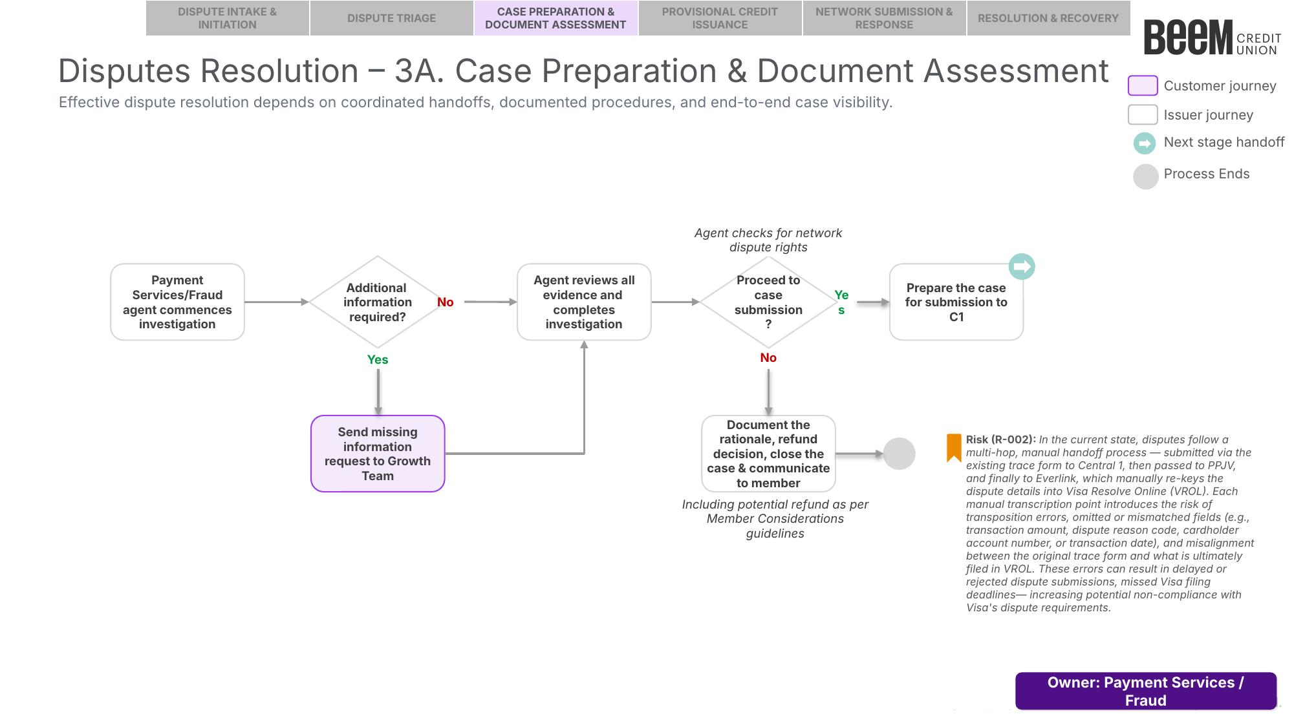

6.2 Procedure
The following procedure provides a step-by-step outline of the activities performed by the assigned Payment Services Team member or Fraud Specialist as part of case preparation and document assessment.

6.2.1 Commence Investigation
Upon proceeding from Stage 2 — Dispute Triage, the assigned Payment Services Team member or Fraud Specialist commences investigation of the case:
  - Fraud Prevention Department: please refer to the Visa Debit Card Fraud Investigation Process. Once complete, proceed to Section 6.2.5 — Assess Network Dispute Rights and Proceed to Case Submission.
  - Payment Services Team: please refer to Section 6.2.2 — Review Referral and Available Information below.

6.2.2 Review Referral and Available Information (Payment Services Team)
Upon receipt of the case, the Payment Services Team member must review the case and available information to determine whether sufficient information is available to proceed with the investigation. The agent should verify that the following information is available for review, including but not limited to:
  - Member and account information (suggested source: CRM case, DNA).
  - Transaction details, including date, amount, merchant, and network type (suggested source: CRM Transaction Details, DNA).
  - The member’s dispute narrative and reason for dispute (suggested source: CRM Dispute Narrative).
  - The completed ATM/POS Trace Request fields, including method of instruction and any prior merchant contact details (suggested source: CRM case).
Based on the above, determine whether there is sufficient information available to conduct the investigation:
  - If the information is complete: proceed to Section 6.2.3 — Conduct Investigation.
  - If information is incomplete: send a missing information request to the Growth Team. Once sufficient information is received, proceed to Section 6.2.3 — Conduct Investigation.

6.2.3 Conduct Investigation (Payment Services Team)
The Payment Services Team member should review the available information for the following red flags:
# | Red Flag Check | Suggested Source
1 | Transaction details (date, amount, merchant) on file do not match the member’s claim or the ATM/POS Trace Request. | CRM, DNA
2 | The disputed amount has already been reversed or refunded by the merchant. | DNA
3 | The member has a history of frequent or repeated disputes. | DNA
Capture the investigation notes and findings in the CRM case, then proceed to Section 6.2.4 — Determine and Record Investigation Outcome.

6.2.4 Determine and Record Investigation Outcome (Payment Services Team)
Based on the totality of evidence identified during the investigation, including the red flags identified in Section 6.2.3, the Payment Services Team member should determine whether the dispute is valid.
  - If the dispute is valid (no red flags identified, or identified red flags do not warrant denial): document the outcome in the CRM case notes, and proceed to Section 6.2.5 — Assess Network Dispute Rights and Proceed to Case Submission.
  - If the dispute is not valid (red flags identified): document the rationale in the CRM case notes, close the case by setting the CRM case status to “Closed”, and communicate the outcome to the member. This procedure ends.

6.2.5 Assess Network Dispute Rights and Proceed to Case Submission
Once investigation is complete (Fraud: per the Visa Debit Card Fraud Investigation Process; Non-Fraud: per Sections 6.2.2 – 6.2.4 above), the assigned agent should assess whether the dispute is eligible for submission, based on the investigation findings and the applicable network dispute rights criteria (see the Everlink — Visa Debit Program Chargeback User Guide):
- Non-Fraud: the dispute must have a valid dispute code (i.e., fall within one of the applicable Visa Dispute Category 12 or 13 conditions).
- Fraud: the disputed transaction must not be a Secure Electronic Commerce Transaction that was fully 3-D Secure authenticated (Card-Not-Present), and the dispute must fall within the limit of 35 disputes for a single cardholder PAN within the previous 120 calendar days — a submitted dispute beyond this threshold is invalid.
  - Note: where a case involves more than 35 disputed transactions on the same PAN, the Fraud Specialist should initiate disputes for the 35 transactions with the highest dollar amount.
Based on the above, determine whether to proceed to case submission:
  - If proceeding to case submission: set the CRM case status to “Submitted to Central 1”. Prepare the case for submission to Central 1 (C1), and proceed to Stage 4: Network Submission & Response.
  - If not proceeding to case submission: document the rationale and refund decision (including any potential refund as per the Member Considerations guidelines) in the CRM case notes, close the case by setting the CRM case status to “Closed”, and communicate the outcome to the member. This procedure ends.

